Addition to LECKY Dissertation
3/16/99
This section will be inserted as 6.5 in my dissertation. The equation editor on my laptop is broken, so the equations are temporarily written in “english” below. I’ll be able to fix this up over the weekend.

Motion Planning
As an example of how scouting can be applied to much more complex problems, it is instructive to examine the problem of motion control. In particular, scouting can be used to plan a movement in advance, thereby drastically reducing the complexity of the required control system.
Traditionally, motion control is implemented as feedback system in which the desired position r(t) of the system is compared to the current position y(t) of the system, and the resulting error signals e(t) are used to develop suggested actuator inputs u(t). In such a scenario, a dynamic model of the system, or plant, is essentially inverted to enable the prediction of what actuator inputs would be required to achieve a particular motion.
Unfortunately, this inversion of the system model is often quite difficult, and indeed the bulk of the motion control literature is concerned with linear system theory since linear systems are the only ones which can be analytically inverted in practice.
Nonlinear systems are more common than linear systems. In fact, virtually all systems demonstrate significant nonlinearity in practice. Consider the simple inverted pendulum shown below:
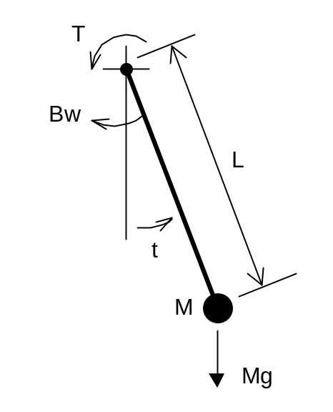
Figure 1: Inverted Pendulum
In this simple system, a mass M suspended from an arm of length L is free to rotate completely around the upper pivot point. We consider the influence of gravity, Mg, on the mass, and consider that the pivot has a frictional drag property B omega that is proportional to the rotational velocity of the pendulum.
This 2nd degree system has two state variables y1 and y2 which will can be called by their more common names, theta and omega. The angle theta is the angle of the pendulum from hanging vertically, and omega is its rotational velocity. We consider a single input u1, more commonly called tau, which is a torque applied about the pivot.
A multidimensional system equation is commonly decomposed into multiple 1st order differential equations for analysis purposes. The system equations for the inverted pendulum are:
Theta dot = omega
Omega dot = 1/MLL (tau – B omega – MGL sin(theta))
It is the sin(theta) term which introduces significant nonlinearity into even this simple system. A closed form solution of these equations is very difficult to obtain. For an arbitrary tau not of a specific form, an analytical solution is probably impossible.
Given a command input r1 and r2, which could for example be theta=pi (straight up) and omega=0 (motionless), traditional motion control would look at the theta,omega error and try to generate the necessary tau to move in the correct direction. The nonlinear nature of the system model makes this position-to-actuator input conversion very difficult.
Several techniques for controlling nonlinear systems are proposed in the literature. The most common techniques, however, involve piecewise linearization of the system model to enable more classical analytical approaches to be used in at least a piecewise sense to develop a control methodology. For inverting the pendulum, a half-dozen or more control regions would have to be selected, over which a linear approximation to the sin(theta) term would be created.
It is possible to propose a much different approach to motion control, however. In this approach, each motion will be planned in advance, much the way the human motor cortex is known to be involved in planning long before movement begins. In motion planning, we try to develop a “trajectory” which consists of a time history of theta(t) and omega(t) that leads to the desired final state. This trajectory is driven by a proposed tau(t), which would be the exact actuator inputs required to drive the system if the system model were perfect and there were no outside influences during movement.
In a real-world environment, the motion plan serves as an intelligent guideline for the motion which can be fed into a very simple feedback controller for actual execution. In fact, since the steps of the plan can be spaced arbitrarily close together, this motion plan can be used with a series of piecewise linear controllers to build extremely accurate nonlinear system controllers.
A scouting approach to motion planning involves applying arbitrary actuator inputs at a particular rate and then seeing if the model moves as was hoped. If a scout discovers an actuator input sequence that leads the system to the desired final state, then a motion plan has been found. Other scouts might find solutions with fewer “steps,” which would normally be associated with faster execution time, but which might also be set up to indicate lower total power consumption or some other metric of solution quality.
A direct application of this idea, however, is doomed to fail, since applying a stream of random torques to our inverted pendulum is extremely unlikely to invert it. However, knowledge of the form of typical solutions to motion control problems can reveal a way to abandon this scout-0 approach in favor of a scout-1 or even scout-2 type formulation.
This is the case since actuator inputs in real motion control problems typically follow reasonably smooth curves. An extremely short duration actuator input spike has little effect on dynamic systems, and is also likely to cause motions that are jerky or awkward, not smooth. This by its very nature suggests that the regulation of actuator inputs will be a smooth and relatively slow-varying operation in any good solution.
In generating a “random” torque profile, then, a scout should not consider setting the torque level to a random value at each step. Rather, the scout should merely adjust the torque slew rate; that is, the rate of change of the torque. Furthermore, it makes no sense to rapidly alternate between slewing torque up and then slewing it down, unless the torque value is near zero. We can in fact reduce the number of torque slew actions to a fairly small number without losing the ability to generate complex torque profiles. In this example, the following five actions will be considered:
- Fast ramp increase
- Slow ramp increase
- Maintain current force
- Slow ramp decrease
- Fast ramp decrease
This does not mean that the number of choices possible for each action need be 5. A scout should only consider moving one increment in either direction, since it should not be necessary to follow a rapid torque increase with a rapid decrease. Following action 2, for example, a scout should only consider actions 1, 2, or 3. Following action 1, it should only consider actions 1 or 2. Thus, the average branching factor for the force adjustment decision problem is reduced to 3*3 +2*2 / 5 = 2.6.
To determine whether a torque profile moves the system to the desired position, the system must be simulated. This is easily accomplished with numerical integration of the system equations. Though the equations may be nonlinear, this is immaterial for numerical integration since we are only simulating the system in a forward direction and not attempting to invert it.
Since the actuator inputs are specified by a slew rate, the inputs must be adjusted at each step of the numerical integration according to the slew rate selected. In this way, an accurate numerical integration, which requires small time steps, can be coupled with a more sensible slew adjustment rate, which would be expected to need updating much less frequently.
Based on this discussion, a simulation program for motion planning will now be developed.

Situation And Action Structure
Situation will be represented by theta and omega, and as the simulation progresses it will update the future time so it is easy to see how far in the future a given situation is.
// Situation
// theta,omega,t
#define theta s[0]
#define omega s[1]
#define t s[2]
The action structure keeps track of the current tau and the dTau slew rate. The direction of the tau slew is reprented as an integer from –2 to 2, representing from fast decrease to fast increase.

// Action
// dTau,Tau,dt
#define dir a[0]
#define dTau a[1]
#define Tau a[2]
#define dt a[3]

Pick Action
The Pick Action functional unit selects a new slew rate for each actuator input. This new rate is either the same as, or one increment higher or lower than, the current slew rate.
The PickAction simulation code simply looks at the last action, which specifies a slew direction from –2 to 2. It adjusts this value up to one step in either direction without going below –2 or above 2. This slew index is then multiplied by a motion constant to create the physical tau slew rate. In addition, the PickAction code anticipates what the final torque will be after the next set of numerical integrations. If the slew rate chosen would cause the torque to go out of limit, it adjusts the slew rate such that the torque will just barely stay in limit.
void PendulumSimulator::PickAction(double* a)
{
int curDir=dir;
int d;
if(curDir==-2)
{
d=rand()%2;
}
else if(curDir==2)
{
d=rand()%2-1;
}
else
d=rand()%3-1;

curDir+=d;
dir=curDir;

dTau=(double)(curDir)/2.*tauSlew;

// anticipate and prevent overshooting Tau limits
double tauDist=dTau*(double)integrationsPerStep;
if(Tau+tauDist>maxTau)
dTau=(maxTau-Tau)/integrationsPerStep;
else
if(Tau+tauDist<minTau)
dTau=(minTau-Tau)/integrationsPerStep;
}

Next Situation
The Next Situation unit implements a direct numerical integration of the system model, driving it forward with the specified actuator inputs, and slewing them at the rates selected by the PA unit. Given the current model position, the NextSituation simulation code integrates the system model a programmable number of times to move the model forward. This is a simple Euler integration; more advanced techniques are possible but not necessary for small enough step sizes.
void PendulumSimulator::NextSituation(double* s,double* a)
{
for(int i=0; i<integrationsPerStep; i++)
{
// straight Euler technique; walk the system model
Tau += dTau; // keep Tau ramping

double thetadot = omega;
double omegadot = MLLinv * (Tau - B*omega –
MGL*sin(theta));

theta = theta + thetadot*dt;
omega = omega + omegadot*dt;

t+=dt;
}
}

Goal Check
The Goal Check unit simply checks to see if the final theta and omega of the model are within limits, although two other commented out possibilities are shown in the simulation code. One example forces the solution to occur within a particular time window. This would cause a good position/velocity to fail unless it was inside the specified time window. The other modification shows steady state checking, in which the model would be required to be inside the final position/velocity window for several time periods before a successful trajectory would be declared.
BOOL PendulumSimulator::GoalCheck(double* s)
{
// EXAMPLE: Force solution at a specific time
//if(t<4.5 || t>5.0) return FALSE;

// STANDARD: Are we in position/velocity spec
if(fabs(theta-finalTheta)<finalThetaTol &&
fabs(omega-finalOmega)<finalOmegaTol)
return TRUE;
else
return FALSE;

// EXAMPLE: Force steady state solution: check to see
// if we have been in the final state for at least K timeslots
//if(fabs(theta-finalTheta)<finalThetaTol &&
// fabs(omega-finalOmega)<finalOmegaTol)
//{
// nConforming++;
// if(nConforming>K) return TRUE;
// else return FALSE;
//}
//else
//{
// nConforming=0;
// return FALSE;
//}
}

Simulation with Plenty of Torque
A complete simulation was developed and tested. The complete system was simulated for several different types of constraints. In each case, the goal of starting with a motionless hanging pendulum (theta = omega = 0) and inverting it (theta=pi, omega=0) was set. A goal tolerance of position +- 2 degress and rotational velocity +- 2 degrees/sec was allowed. M and G were set to 1, and L was set to 2. The system model was integrated for eight 0.025 s steps after each torque slew choice was made. Thus, the motion plan is updated at a 5 Hz rate, and the model simulation proceeds at 40 Hz.
The following motion plan resulted from running 30,000 scouts with torque constrained to a range of –8 to +8. The “best” scout was chosen based on number of actions, which translates to the actual runtime of the motion.
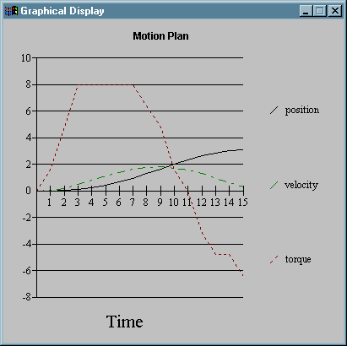
Figure 2: Minimally Constrained Motion Plan
This represents a 15-step solution in which the torque slew rate is adjusted 15 times. Since each slew choice is maintained for eight 0.025 s integrations, an adjustment choice is made every 0.2 S and the entire solution takes 3.0 s. As expected, the winning plan involves slewing torque to the maximum as fast as possible, and then slewing to a large negative amplitude at the right moment to arrest motion just as the pendulum hits the apex.
As a reminder, to actually execute this motion plan, the theta(t) and omega(t) profiles would be fed to a simple motion controller. This controller could make use of the tau(t) plan actuator input and merely adjust torque slightly up or down from that level based on positional deviation from plan. In this regard, the motion controller becomes much less complex for a planned motion such as the one generated by the scouting approach.

Simulation with Torque Severely Constrained
The solution becomes much more interesting when torque is constrained to stay between –1.5 and 1.5. The best results of 30,000 scouts with all other parameters held constant is shown below.
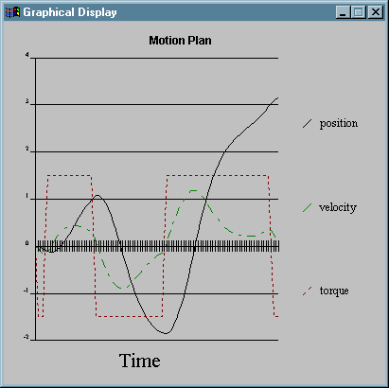
Figure 3: Symmetrically Constrained Motion Plan
Here, the maximum torque of 1.5 is not enough force to lift the mass directly to the vertical position. The found solution instead swings the weight forward, backward, and then forward again to achieve inversion. Developing an analytical technique that would have discovered this solution is difficult to imagine. Using scouting, however, if there is a way to achieve the goal, it will eventually be discovered. The solution displayed required 100 scout actions, representing an elapsed time of 20 s to achieve the goal.

Simulation with Assymetric Torque
If torque is constrained assymentrically from –6 to 2, a sensible solution is also found.
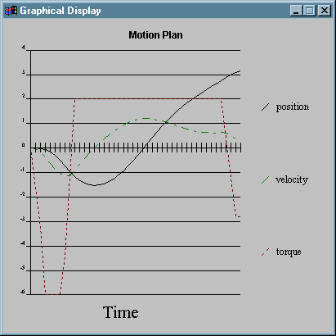
Figure 4: Assymetrically Constrained Motion Plan
This solution required 44 scout actions, representing 8.6 s motion time. The strong negative torque is used to rock the pendulum back approximately 90 degrees (1.5 rad), and then the torque is slewed to its maximum value to swing forward and up to the vertical position.

Simulation with Nonlinear Damping
As a final illustration of the power of forward simulation, this example uses non-linear damping of the form:
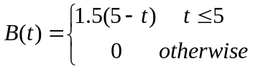
Torque is constrained to –1.5 to 1.5, and the following 49-step (9.8 s) solution is found by 10,000 scouts:
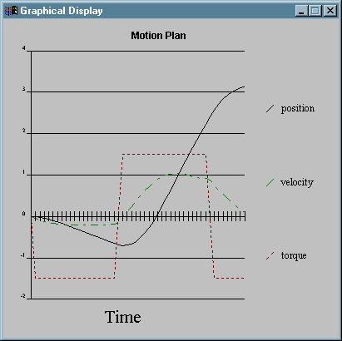
Figure 5: Constrained Motion with Non-linear Damping Plan
Here, since damping decreases with time, it makes most sense to move backwards at the most negative torque until nearly the midpoint of the motion, at which time damping is nearing 0. Now, we slew to maximum torque and rapidly hit maximum velocity. Braking torque is applied earlier than in the previous examples since there is no longer any braking assistance from the damping.

Motion Planning Summary
The motion plans developed by this simple example program are in many ways quite surprising. Without knowing how they were developed, an observer would be tempted to say that they exhibited insight, cunning, grace, and elegance. Human beings, masters at fluid motion control representing elegance and grace, are often surprised that a machine could “think” of such a smooth and efficient solution.
Of course, once the ghost in the machine is understood, the elegance is easily explained. The scouting system has tried literally thousands of torque profiles and merely selected the one that achieved the goal as quickly as possible. The interesting thing about these solutions is that they were directly generated from nothing more than an actuator-to-movement model of the system, which can be learned purely from experimental data. In effect, this solution proposes a model that explains how an unintelligent system can develop extremely insightful solutions using nothing more than a model of experience developed from trial-and-error.
While this example of scouting behavior is in some ways more impressive than the 8-puzzle problems used to illustrate the technique earlier in the dissertation, there is really nothing different about this application of scouting. The only creative part of the process involves how the problem is represented to the architecture. Of course, other complex problems could be similarly structured to use scouting. There is nothing special about solving motion planning problems, just as there is nothing special about solving 8-puzzles.

Bibliography
The following three references will be added to the Bibliography:
Franklin, Gene F., Powell, J. David and Workman, Michael L. (1990). Digital Control of Dynamic Systems, 2nd Edition. Addision-Wesley.
Kirk, Donald E. (1970). Optimal Control Theory. Prentice-Hall.
Lecky, John E. (1999). Using Scout Clusters for Motion Planning. International Joint Conference on Neural Networks. To be presented 7/99.

Franklin, Powell, and Workman (1990), p. 2
As stated in Franklin, Powell, and Workman (1990), p. 518
Lecky (1999). To be published in Conference Proceedings.

